Assignment 4
- Vijaya Karunya
2303A52364
Batch : 32
- Customer Email Classification
A company receives a large number of customer emails every day
and wants to automatically classify them into the following
categories:
• Billing
• Technical Support
• Feedback
• Others
Instead of training a new machine learning model, the company
decides to use prompt engineering techniques with an existing large
language model.
Tasks
1. Prepare five short sample emails, each belonging to one of
the above categories.
2. Write a zero-shot prompt to classify a given email into one of
the categories without providing any examples.
3. Write a one-shot prompt by including one labeled email
example and ask the model to classify a new email.
4. Write a few-shot prompt by including two or three labeled
email examples and ask the model to classify a new email.
5. Compare the outputs obtained using zero-shot, one-shot, and
few-shot prompting techniques and briefly comment on their
effectiveness

Prompt:
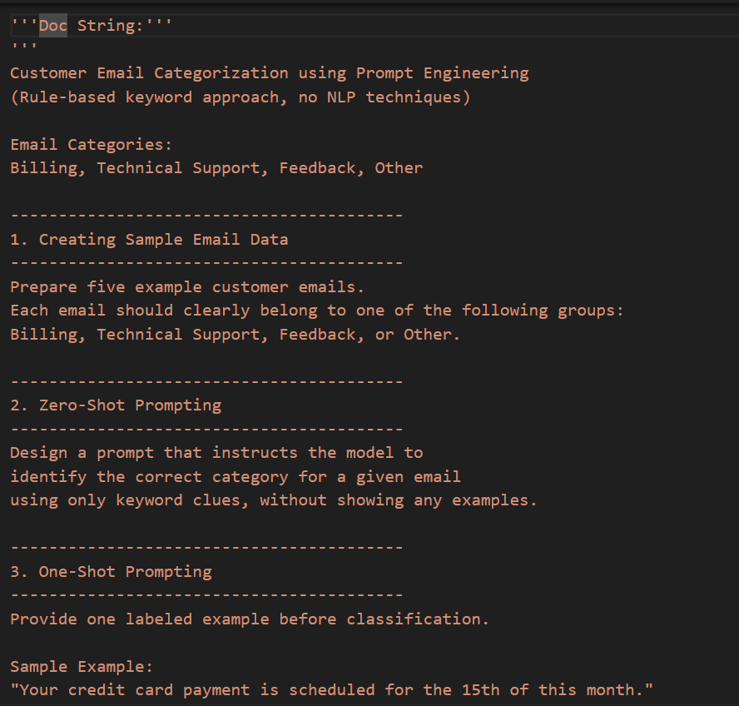
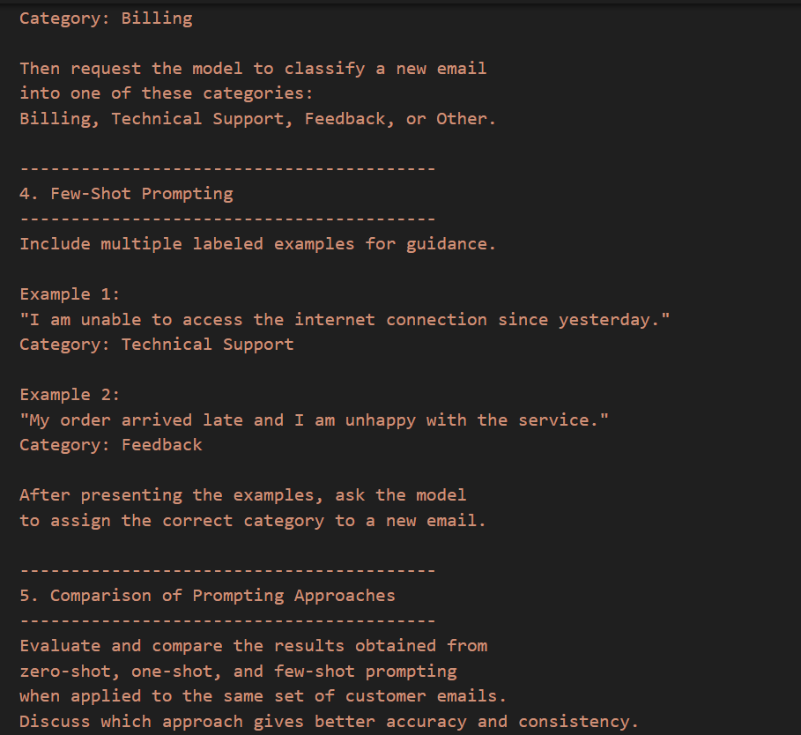

Code:
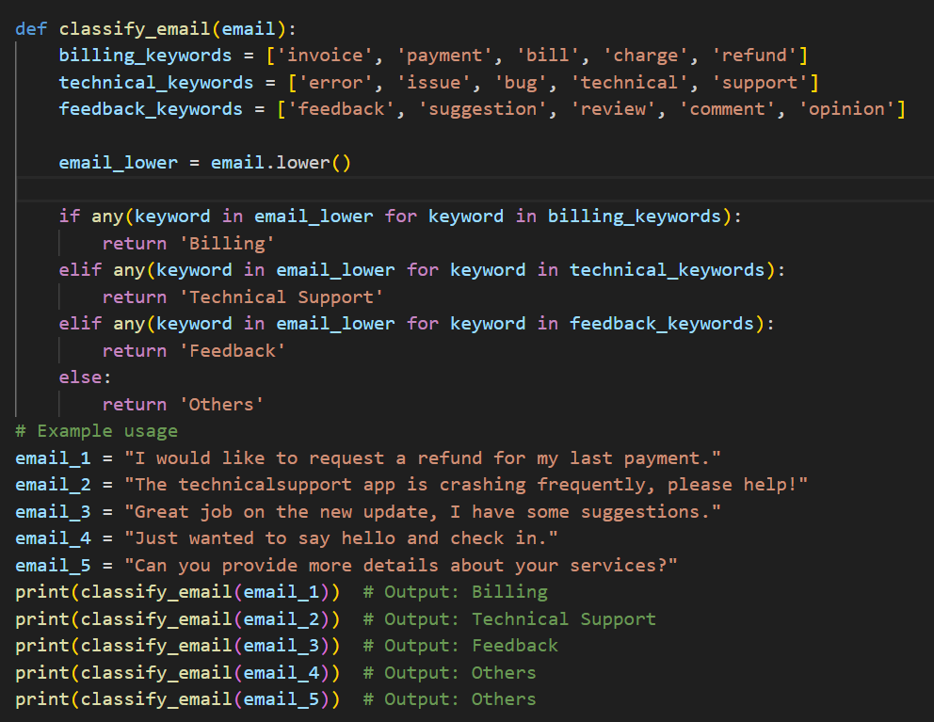
Output:
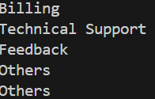
Suggestion:
Organizations should ensure that automated email classification systems are transparent and fair to all customers. Users have the right to accurate handling of their concerns without bias or misclassification. Clear categories help route issues quickly, protecting customers’ right to timely support and resolution. Human oversight should be maintained to correct errors and respect customer dignity. Data used in classification must also be handled responsibly to protect privacy and trust.

- Intent Classification for Chatbot Queries
A company wants to deploy a chatbot to handle customer queries.
Each query must be classified into one of the following intents:
Account Issue, Order Status, Product Inquiry, or General Question
using prompt engineering techniques.
Tasks to be Completed
1. Prepare Sample Data
Create 6 short chatbot user queries, each mapped to one of
the four intents.
2. Zero-shot Prompting
Design a prompt that asks the LLM to classify a user query
into the given intent categories without examples.
3. One-shot Prompting
Provide one labeled query in the prompt before classifying a
new query.
4. Few-shot Prompting
Include 3–5 labeled intent examples to guide the LLM before
classifying a new query.
5. Evaluation
Apply all three techniques to the same set of test queries and
document differences in performance.

Prompt:
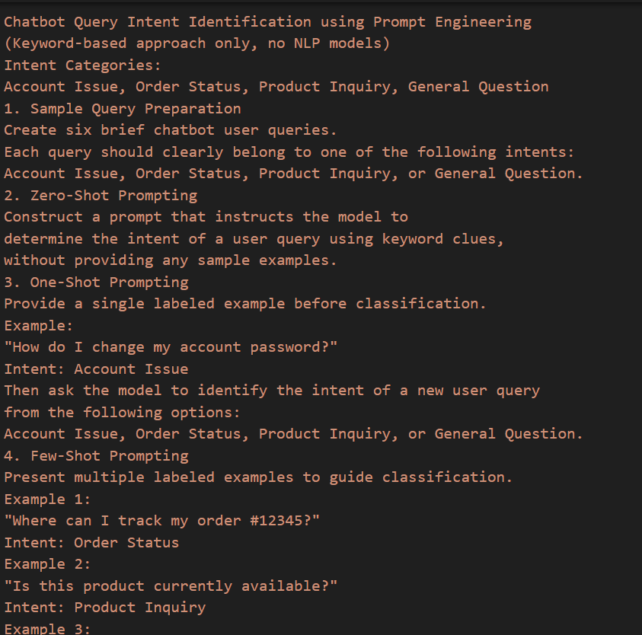
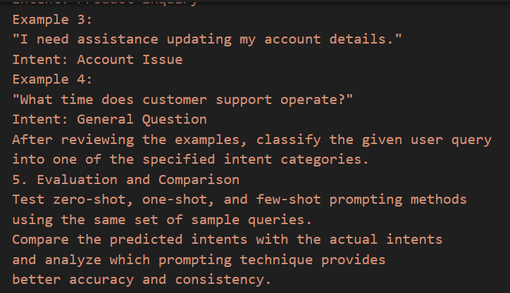

Code:
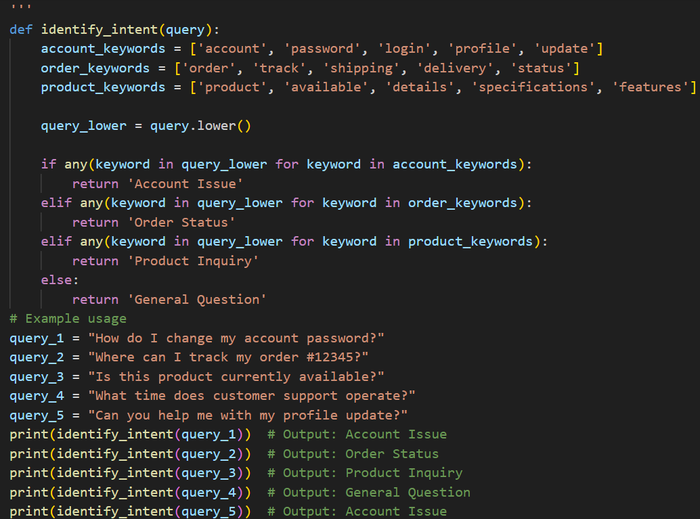
Output:
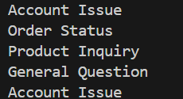
Suggestion:
Using keyword-based prompts is a good way to classify chatbot queries without building complex models. Zero-shot prompts are quick but may miss some details. One-shot prompts help by showing one clear example. Few-shot prompts usually work best because they give more guidance. It is also important to check results with real queries to make sure the chatbot works correctly

- Student Feedback Analysis
A university collects student feedback and wants to categorize
comments as Positive, Negative, or Neutral.
Questions:
a) Write a Zero-shot prompt to classify feedback sentiment.
b) Provide a One-shot prompt with one feedback example.
c) Create a Few-shot prompt using multiple labeled feedback
samples.
d) Explain how examples improve sentiment classification
accuracy
Prompt:
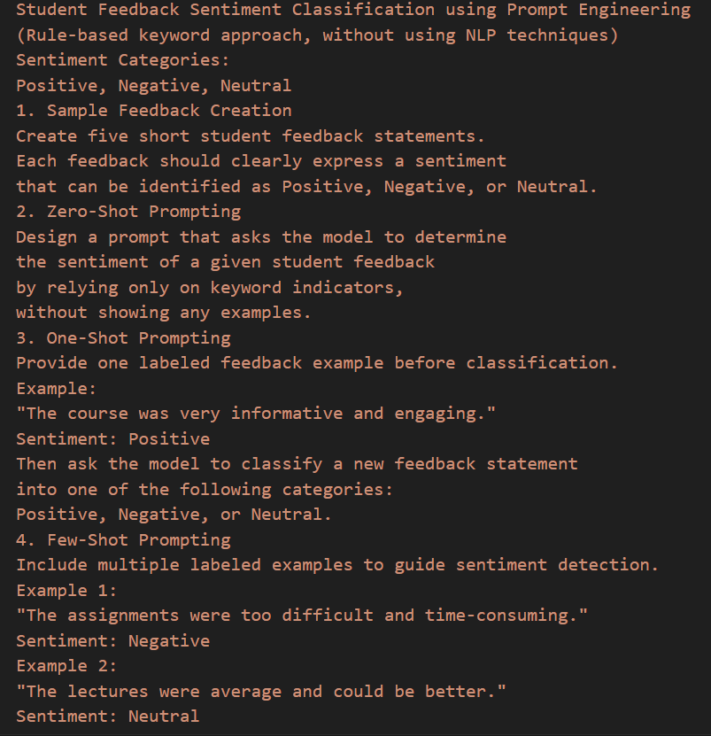
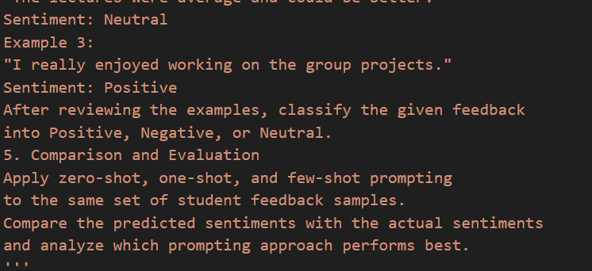

Code:
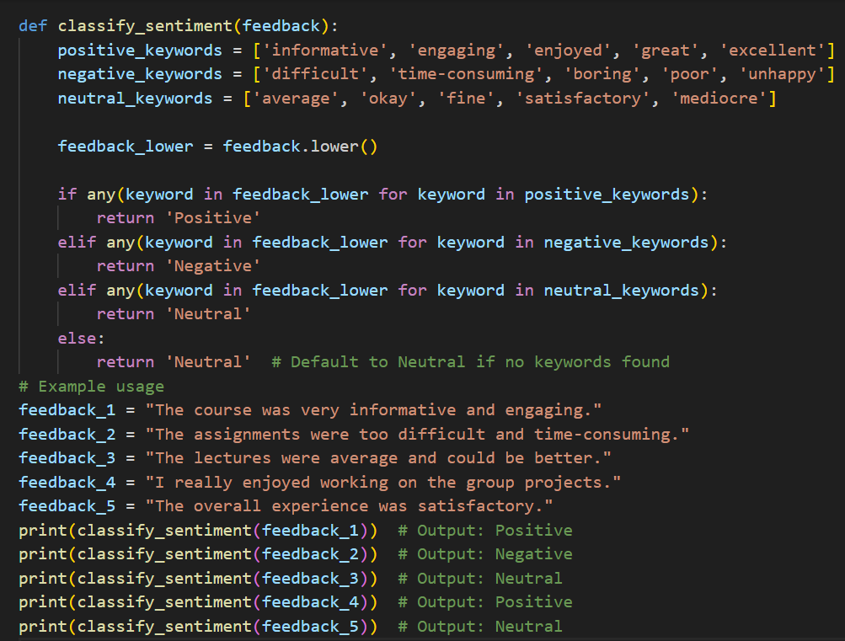
Output:
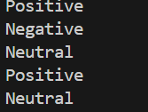
Suggestion:
Using keyword-based prompts is an easy way to understand student feedback without using complex NLP methods. Zero-shot prompting is fast but may give wrong results for unclear feedback. One-shot prompting improves accuracy by showing one example. Few-shot prompting works best because it gives clear guidance through multiple examples. Always compare results with actual feedback to ensure correct sentiment classification.

- Course Recommendation System
An online learning platform wants to recommend courses by
classifying learner queries into Beginner, Intermediate, or Advanced
levels.
Questions:
a) Write a Zero-shot prompt to classify learner queries.
b) Create a One-shot prompt with one example query.
c) Develop a Few-shot prompt with multiple labeled queries.
d) Discuss how Few-shot prompting improves recommendation
quality.
Prompt:
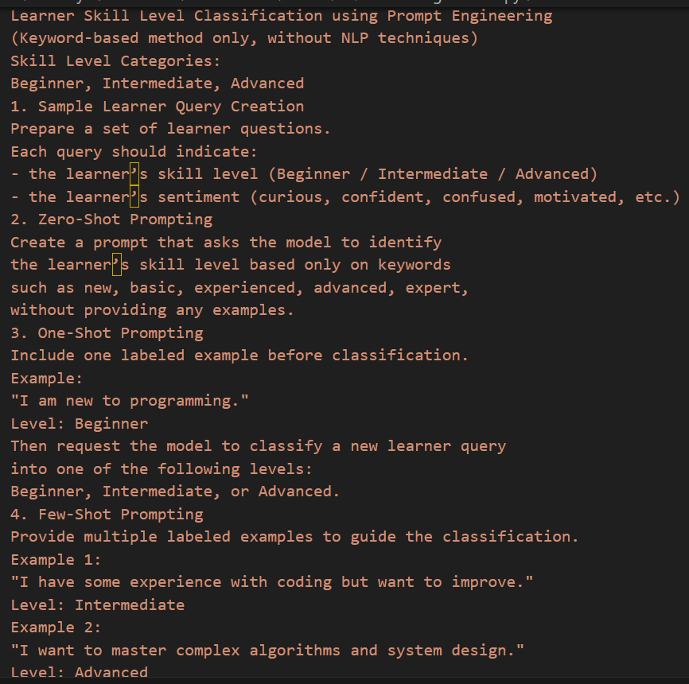
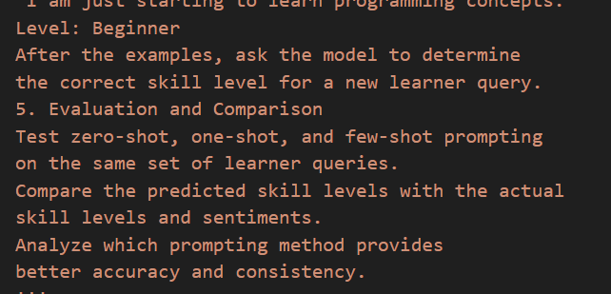

Code:
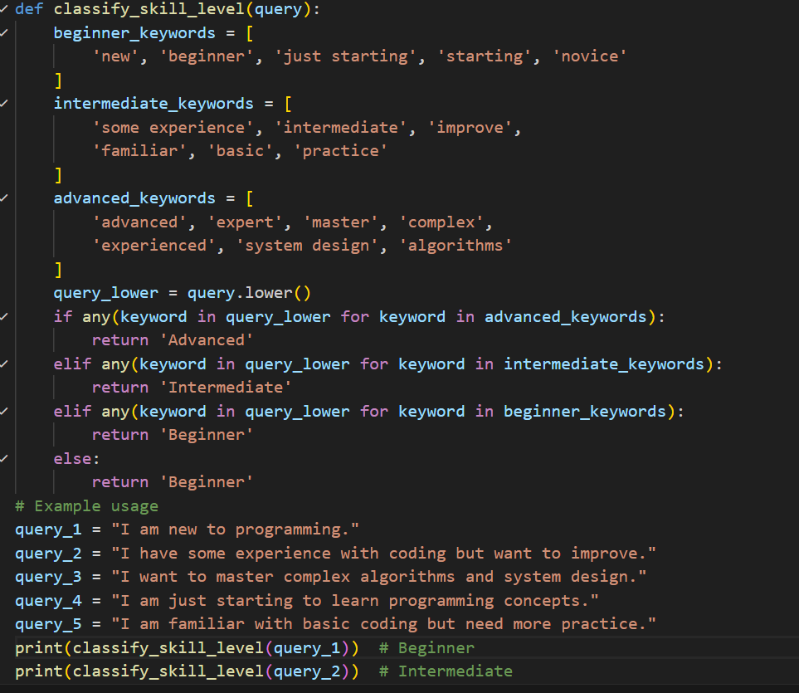
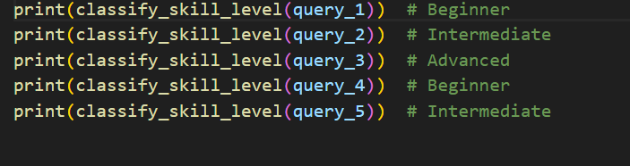

Output:
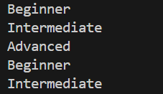
Suggestion:
Classifying learner queries using keywords is an easy and practical approach without using NLP. Zero-shot prompting is quick but may not always be accurate. One-shot prompting helps by giving a clear example to follow. Few-shot prompting usually works best because it shows multiple patterns. Comparing results with actual learner levels helps improve accuracy.

- Social Media Post Moderation
A social media platform wants to classify posts into Acceptable,
Offensive, or Spam.
Questions:
a) Write a Zero-shot prompt for post moderation.
b) Convert it into a One-shot prompt.
c) Design a Few-shot prompt using multiple examples.
d) Explain the challenges of Zero-shot prompting in content
moderation.
Prompt:
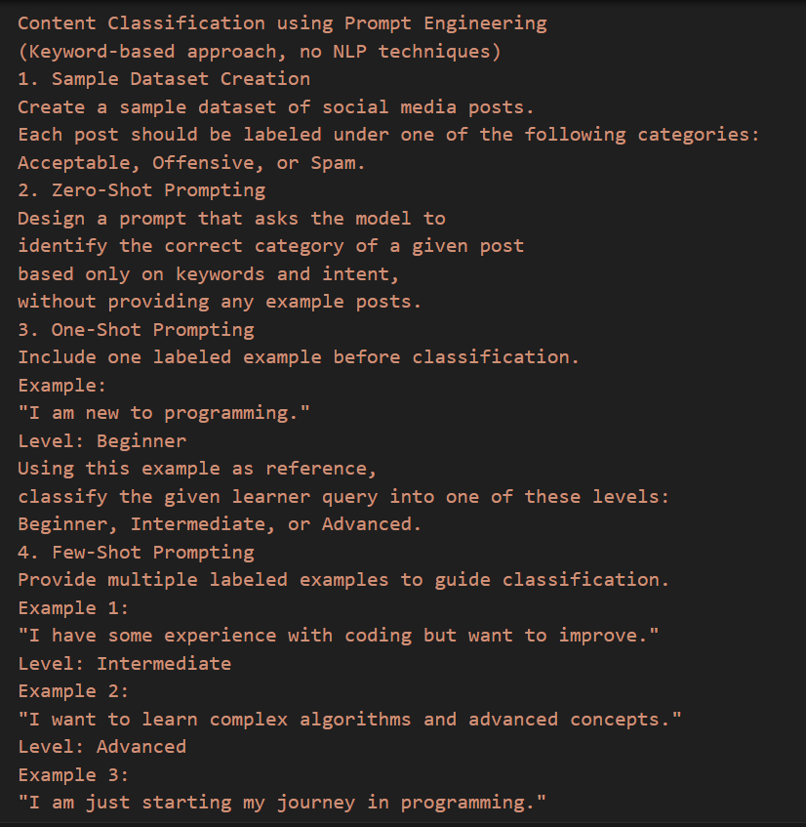
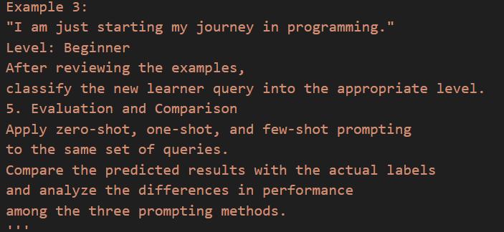
Code:
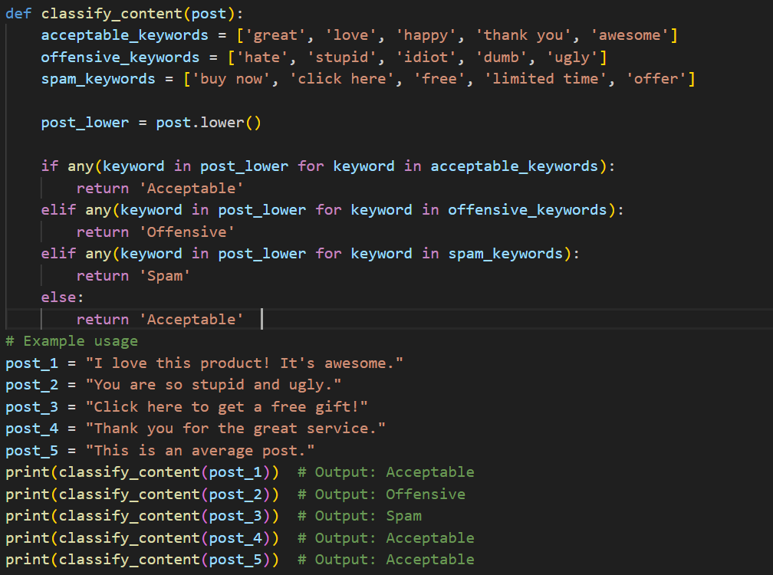
Output:
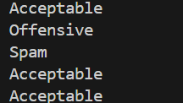
Suggestion:
Using keyword-based prompts is a simple way to classify social media posts without complex methods. Zero-shot prompting is fast but may not always be accurate. One-shot prompting works better by giving one clear example. Few-shot prompting gives the best results because it shows multiple patterns. Comparing outputs with actual labels helps improve reliability.

